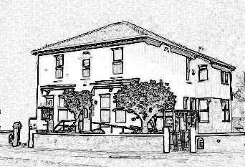
Dr R Caudwell
107 Liverpool Road
Birkdale
Southport
PR8 4DB

Tel: 01704 566646
Fax: 01704 550858

Dr S Biswas
Dr R Bonsor

Practice Management
Nicole Marshall
Kelly Riley-Bridges

Date
Specialist’s name
Hospital Specialty
Hospital name and address

Dear Colleague
Your full name
Your date of birth Your NHS Number (if you know it)
Your address
Your preferred telephone number

Our mutual patient is receiving care from you for:

Write your original problem here

They await a follow-up appointment and / or treatment, but report the following change in their condition since your last contact with them:

Explain briefly what has changed since your last contact with the specialist

We request that you take the following action:

- Review the patient’s hospital notes alongside this letter to determine whether their care might be expedited

- Contact the patient directly to inform them the outcome of that decision, and their likely wait for further care

- File this letter and document your decision in the patient’s medical record.

Yours faithfully
Drs Caudwell, Biswas & Bonsor

