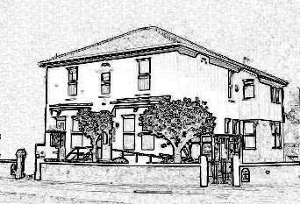
Dr R Caudwell
107 Liverpool Road
Birkdale
Southport
PR8 4DB

Tel: 01704 566646
Fax: 01704 550858

Dr S Biswas
Dr R Bonsor

Practice Management
Nicole Marshall
Kelly Riley-Bridges

Date
Outpatient Appointments
Hospital name and address

Dear Sir / Madam

Your full name
Your date of birth Your NHS Number (if you know it)
Your address
Your preferred telephone number

This patient was referred to you for assessment of:

Write your original problem here

They await a first appointment, but report the following change in their condition
since referral:

Explain briefly what has changed since The Family Surgery referred you to the specialist

We request that you take the following action
- Pass the original referral letter and this letter to a clinician to determine whether their assessment might be expedited

- Contact the patient directly to inform them the outcome of that decision, and their likely wait for an appointment

- File this letter, and document your decision, in the patient’s hospital medical record.

Yours faithfully
Drs Caudwell, Biswas & Bonsor

